

Databases
Assessment 1: Database Model with annotations
Module Coordinator: Edward Longford

Date of submission:
Number of words: 500
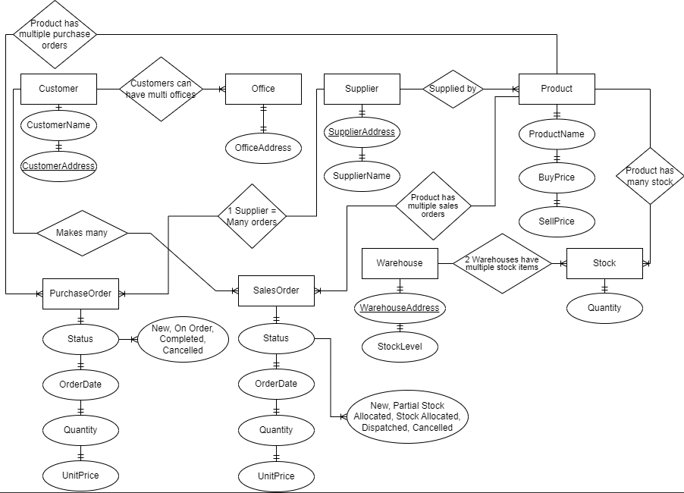
Choice of Relationships:
I decided to have separate tables, for customers, offices, suppliers, products, purchase orders, sales orders, warehouses, and stock to create a structured and organized database. This division allows for the retrieval and maintenance of data. Think of it like this, breaking down customer and office information into separate tables allows a 'one-to-many' connection. In this setup, a single customer can have several offices. However, each office connects back to just one customer.
Designing Process:
During the design process, I carefully considered the connections between entities. It was crucial to recognize one-to-many relationships such as a customer having multiple offices, or a product being included in sales orders. These considerations greatly influenced the structure.
Primary Keys:
The selection of keys was driven by the need for identifiers in each table. For example, CustomerID, OfficeID, SupplierID, ProductID, PurchaseOrderID SalesOrderID WarehouseID, and StockID were chosen as keys to ensure uniqueness and facilitate easy access to data.
Normalization:
Daffodil’s database is designed according to the form (3NF). To achieve this level of normalization we focused on eliminating dependencies and ensuring that each attribute is functionally dependent on its primary key. For instance, the status attribute in both PurchaseOrder and SalesOrder tables directly relates to their keys rather, than depending on other non-key attributes.
Data Integrity:
Maintaining data integrity and avoiding data redundancy is achieved through the use of one- to-one one-to-many and many-to-one relationships. For instance, by having tables for addresses such as OfficeAddress, SupplierAddress, and WarehouseAddress we can ensure that unique information is stored without repetition.
Validation, for Normal Form:
To ensure that the database complies with the rules of the Third Normal Form (3NF) I carefully examined dependencies. Ensured that each non-prime attribute depends solely on the primary key. I thoroughly analysed the relationships and dependencies to eliminate any anomalies that could potentially violate normalization principles.
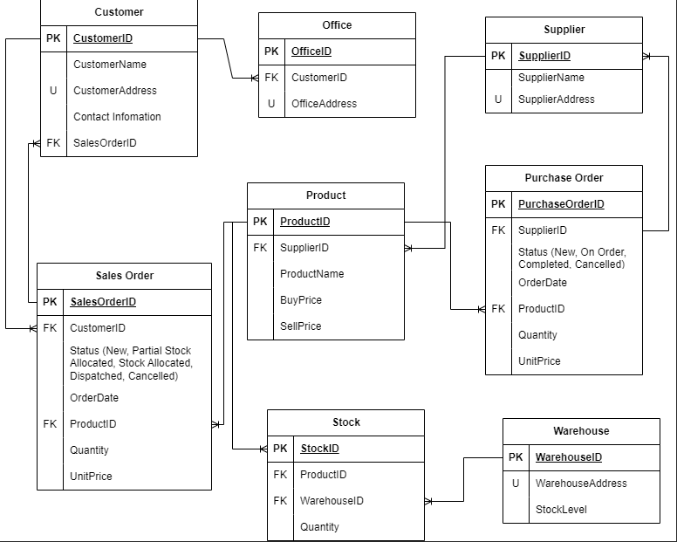
The Daffodil database is in 3NF, and we know this because “All database columns must depend on the primary key, meaning that any column's value can be derived from the primary key only.” (Chapple, 2021)
I made some updates to Daffodil's business model by adding warehouse and stock tables. This way, inventory is well managed. Also, I put status fields in sale and purchase orders. This lets Daffodil track orders in real-time, helping them understand how well their operations are going.
To sum up, I created Daffodil's database by focusing on clearness, quickness, and sticking to standardization rules. By choosing the best relations, main keys, and standardization methods, I made a strong database. This fits Daffodil's business needs and makes handling data easier.
Limitations of ER diagrams:
Relational data specific: The main aim is to showcase connections. ER diagrams just display these links. (LucidChart, 2017)
Not fit for unstructured data: ER diagrams might not work if data aren't exactly split into clear fields, rows, or columns. This also relates to semi-structured data, since only some bits of it can be used. (LucidChart, 2017)
Difficulty combining with a current database: Due to differing designs, merging ER Models with an existing database could be a challenge. (LucidChart, 2017)

References:
Chapple, M. (2021). How Third Normal Form (3NF) Helps Ensure Data Accuracy. [online] Lifewire. Available at: https://www.lifewire.com/normalizing-your-database-third-1019726 [Accessed 9 Nov. 2023].
LucidChart (2017). ER diagram tutorial . [online] Lucidchart. Available at: https://www.lucidchart.com/pages/er-diagrams [Accessed 9 Nov. 2023].

